1. Review from p.14 to p.20 in the text book.

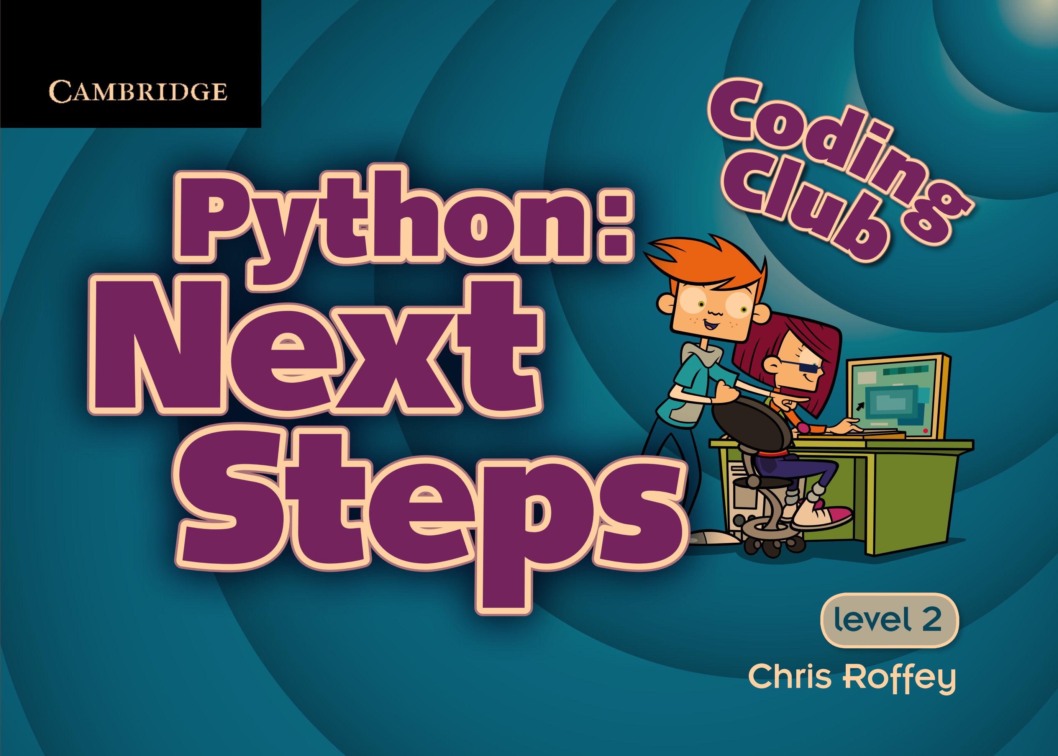

1. Summarize the concepts you think are important among those contents.